**OBJECTIVES**

**1- Operating System Requirements [3 marks]**

Create a table and fill it with the minimum and recommended requirements of the following Operating Systems.

Windows (32-bit and 64-bit)

Windows Server 2012 R2, 2019

Ubuntu Desktop 20.04 LTS. What do the numbers that appear next to the Ubuntu version refer to? And the acronym LTS?

Ubuntu Server 20.04

The latest version of LUbuntu

The latest version of MacOS

Any other OS you like.

|  |  |  |  |  |  |  |  |
| --- | --- | --- | --- | --- | --- | --- | --- |
|  | W. 10  32/64 | W. Server | U.Desk | U.Server | L.Ubuntu | MacOS | Fedora |
| Process. | 1GHz | 1.4 GHz  64 bit | 2GHz  Dual  Core | 1GHz | Single Core Pentium 4 | Imac 2014 or later. Macbook 2015 or later | 2GHz  Dual  Core  Processors |
| RAM | 1GB/ 32bits  2GB/  64bits | 512MB/  2GB  Desktop  Experi. | 4GB | 512MB | 1GB | 4GB | 2GB |
| HDD | 32GB | 32GB | 25GB | 2.5GB | 2GB | 35.5GB | 20GB |
| GPU | DX 9  WDDM 1.0 Driver |  |  |  |  |  |  |
| Display | 800  x  600 | 1024  ×  768 | 1024  ×  768 | 1024  ×  768 | 1024  ×  768 | 640  x  480 | 800  x  600 |
| Internet | Needed | Ethernet  cable  1GB/sec | Needed | Needed | Needed | Needed | Needed |

**2- File systems [2 marks]**

Make a table with the main features of the following file systems. Do not forget to indicate which OS they are used for:

FAT32

extFAT

NTFS

ext4

HFS+

|  |  |  |  |  |  |
| --- | --- | --- | --- | --- | --- |
| Features | FAT32 | exFAT | NTFS | ext4 | HFS+ |
| Max Partition Size | 4GiB -1 | 16 EiB | 16 TiB | 16TB | 8 EiB |
| Max Number of Archives | 268.173.300 | 2.796.202 | 4.294.967.295  2^32 -1 | 4 x 10^9 | 69.254.365.666 |
| Max Volume Size | 10TiB | 64ZiB | 256 TiB | 1024 PiB | 8 EiB |
| Date Limit | 1 January 1980 - 31 December 2107 | 1 January 1980 - 31 December 2107 | 1 January 1601 – 28 May 60056 | 14 December 1901 - 25 April 2514 | 1 January 1904 - 6 February 2040 |

**3- Partition Managers [3 marks]**

Insert a flash drive/external hard drive into the computer.

On Linux run “Gparted”, take a screenshot of the partitions for each device and explain the information that appears.

**\*Without external hdd:**

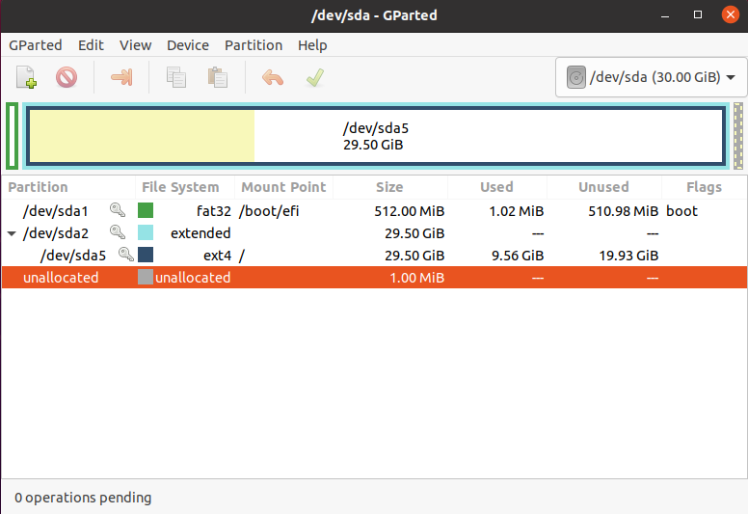

**\*With an external usb connected:**

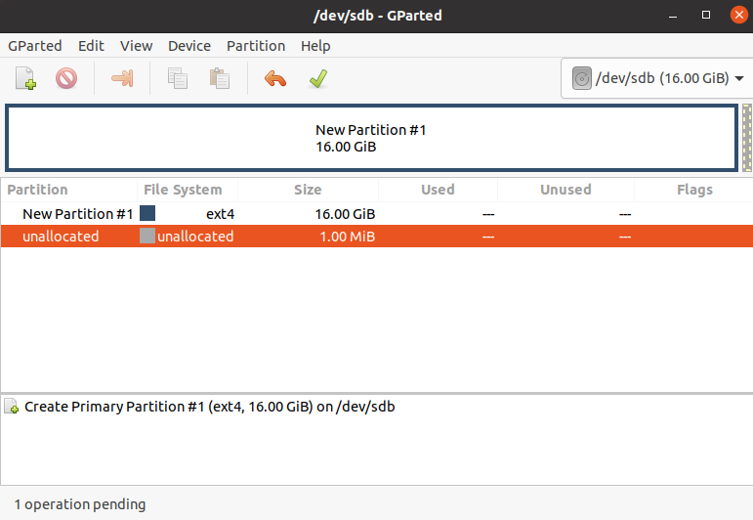

On Windows, for the tool “Disk Manager”, take a snapshot of the partitions for each device and explain the information that appears.

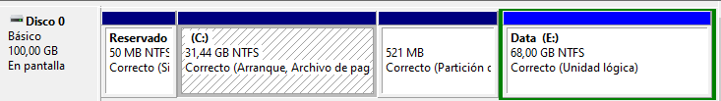

*There are 50MB reserved for the system itself.

31.44GB is the main partition in NTFS format, which contains Windows 10 OS + all the files including the boot ones.

*521MB of a minor partition that is related to:

*68GB of the Data partition in NTFS too, which will contain any extra files that are not related to the OS, such as downloads from the internet, other programs installed…

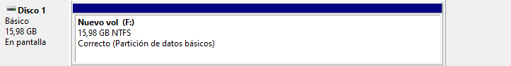

*The usb will only contain 1 main partition of 16GB which match the maximum capacity of the drive completely empty.

Take a screenshot of your home computer partitions and explain the information that appears.

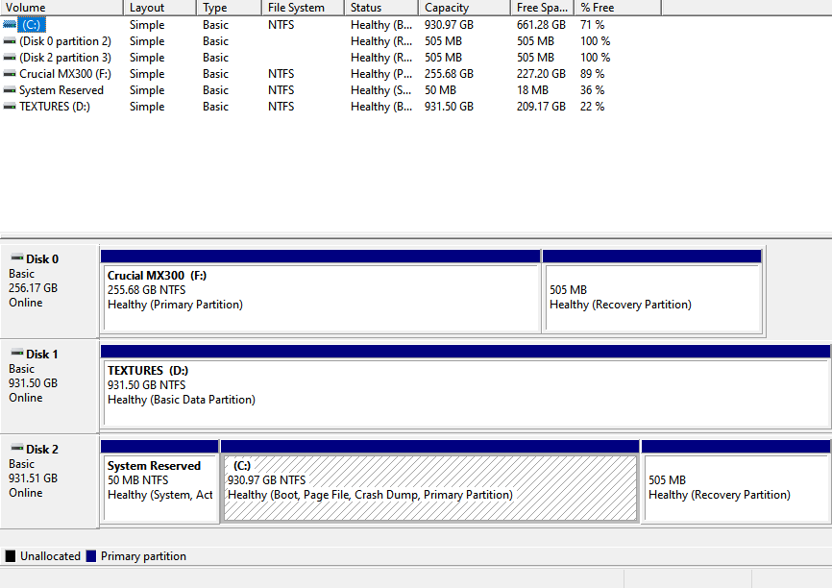

*I have a main pcie ssd which corresponds to the letter C:, it has 2 extra partitions, one of 505MB that serves as a recovery partition and another one of 50MB which contains system files, related to the primary partition which contains the OS and program files.

**4- Partition tables [2 marks]**

Explain the differences between the two types of partition tables: MBR and GPT.

|  |  |  |
| --- | --- | --- |
|  | MBR | GPT |
| Maximum capacity | 2TB | 9.4ZB |
| Max number of partitions | 4 primary partitions | 128 primary partitions(on Windows) |
| Firmware support | BIOS | UEFI |
| Security |  | Verification CRC32 and GUID security copy |